Risk assessment

School Name: | All Saints National Academy
URN Number: | 141410
What are your 3 most significant risks identified in your risk assessment? | Availability of space for the intended numbers  Vulnerability of key children with additional needs  Parents congregating at the gates and drop off and pick up times
Are there any additional issues you wish to flag with the LA in terms of your ability to re-open? | No
This risk assessment has been completed based on the national and local guidance at the time having taken account of the additional risks/hazards/controls specific to this school.
Signature: M Skidmore Date: 17/12/21
The RESET Programme in Walsall

Coronavirus (COVID-19): Risk Assessment Action Plan for opening from 1st June 2020.

All Saints National Academy
Original Assessment conducted by: Nicky Baddeley  Review conducted by: Michelle Skidmore | Job title: Executive Principal/Head of School | Covered by this assessment:  Whole academy
Date of draft assessment: 19/5/20 | Consultation date:- 20/5/20 | Reviewed by Knights Solictors:-22/5/20
Amended date: 23/5/20 for 2020/21  28/8/21 for academic year 2021/22 – 07/10/2021, 29/11/2021 | Approved date:- 25/5/20 | Date of next review: 11/9/20,18/9/20.25/9/20.2/10/20,12/10/20,2/11/20, 28/8/20, 7/10/21  Amended Date : 7/10/21, 29/11/2021, 17/12/2021

AMENDMENTS
- For the purpose of this risk assessment, the term ‘coronavirus’ to refer to coronavirus disease 2019 (COVID-19).
- Schools must ensure that this risk assessment reflects the local setting and context of the school. Staff must be consulted with regard to this risk assessment.
- This risk assessment is not exhaustive and is issued to schools as a template to assist in the production of a comprehensive document that covers the particular circumstance of the setting – as such, the risks and risk controls should be deleted/amended/added-to to reflect the school.
- This should be viewed alongside relevant advice and guidance from the Department of Education and reflect any additional subsequent guidance issued to schools.
- Additional information and considerations that is specific to our local area can be found at: https://go.walsall.gov.uk/covid-19_information/covid-19_-_i_want_to_know/outbreak_management_plan
- For further reference, https://www.gov.uk/government/latest?departments%5B%5D=department-for-education, including the documents below:
  - https://www.gov.uk/government/publications/safe-working-in-education-childcare-and-childrens-social-care/safe-working-in-education-childcare-and-childrens-social-care-settings-including-the-use-of-personal-protective-equipment-ppe?utm_source=27%20August%202020%20C19&utm_medium=Daily%20Email%20C19&utm_campaign=DfE%20C19
  - coronavirus (COVID-19) home testing kits.
  - https://www.gov.uk/government/publications/covid-19-stay-at-home-guidance
  - https://www.gov.uk/government/publications/covid-19-stay-at-home-guidance/stay-at-home-guidance-for-households-with-possible-coronavirus-covid-19-infection?utm_source=28%20November%202021%20C19&utm_medium=Daily%20Email%20C19&utm_campaign=DfE%20C19

Staff will be allocated to classes in learning bubbles.

The sole purpose of this risk assessment is to support schools in preparing for the possibility of providing some face-to-face contact with pupils in year groups, whilst reducing the risk of coronavirus transmission.

Key:
Level of risk prior to control | Identifies the risk before any steps to reduce the risk have been taken
Risk Description: | Outlines the area of concern. This list is not exhaustive and schools should add/amend/delete where appropriate e.g. risks for pupils with complex needs.
Risk Controls: | The measures that will be taken to minimise the risk. These are generic and should be adapted for the school context.
Impact: | L/M/H.
Likelihood: | L/M/H
Responsible person: | The identified staff member(s) responsible for implementing the risk controls.
Date: | The date by which required plans for controls will be in place. ONGOING REFERS TO THIS ASPECT BEING REVISITED DAILY
Line Manager Check: | Sign off to ensure that the risk has been minimised as far as possible.
NAMED STAFF | SC – Sarah Cockshott, Executive Principal/ Head of School MS – Michelle Skidmore SLT – SENIOR LEADERS ONSITE JOSIE BAGLEY & GM – GEMMA MEERS MB – SITE SUPERVISOR MARK BRAZIER OM- OFFICE MANAGER SCT – ST CHAD’S TRUST SGO – Safeguarding Officer MANDEEP BASSI  TEACHING TEAM – TEACHERS & SUPPORT STAFF IN THEIR DESIGNATED BUBBLES

COMMUNICATION INTERNALLY WILL BE ACTIONED VIA WALKIE TALKIE SYSTEM. ROLL CALL COMPLETED AT START OF DAY TO ENSURE COMMUNICATION STREAMS ARE CLEAR

Risk Description/Area of Concern | Level of risk prior to control | Risk Controls | Impact/  Severity | Likelihood | Responsible person | Planned Completion Date | Line Manager Check
The academy is closed due to a local or national lockdown | M | The academy will follow the designated Outbreak Management Plan in the event of a local or national lockdown.  To ensure provision is made for Key Worker and Vulnerable pupils on- site  - Reduction in number of staff and pupils on site  - Class Bubbles created and rotas completed to cover the pupils requiring a space  - Rotas of staff on site to support KW & V pupils, these are allocated on a weekly basis and created and reviewed in line with pupil demand  - Parents are requested to contact Mrs Skidmore on mskidmore@asna.walsall.sch.uk if they require a place on site if they are a keyworker or vulnerable family  - Contact the Catering team to organise lunches for the allocated pupils  To ensure effective provision is made for staff for their own protection  - Rotas of leadership team and office team in order to keep bubbles in the event of a positive case.  - Staff allocated on a weekly rota basis for child facing sessions and remote learning provision  - All staff to wear a face covering at all times within communal areas when in the academy  To ensure that effective online remote learning is created for all learners  - The academy Remote Learning Policy is followed  - Staff upload work onto Google Classroom daily for pupils  - Live lessons will be actioned and a register of pupils kept  - Those pupils who are not online will be contacted by a member of the leadership team  - Work is created that meets the needs of pupils  - SEND pupils receive work that is matched to their needs and in relation to parents, additional support is offered either on or off site and this is checked by SENCO  - Paper packs will be created in exceptional circumstances and in direct liaison with the P or VP  - Paper packs of work are created weekly (Thursday) and quarantined ready for collection by parents on the following Monday  - Packs are sealed and available from the main reception area  - Pupils who have no access to a device within the home, are allocated a laptop and support provided to access the platform  - A Remote Learning Strategy is reviewed for the September 2021 start and is shared with all stakeholders via the academy website  - Acceptable Use Policies are reissued to all stakeholders and they agree and adhere to its content  - Support is offered to any staff and/ or parents in relation to the remote learning platform – Google Classroom  - Attendance of Key Worker and Vulnerable children is monitored and the registers are completed on a daily basis. If children are due on site but fail to attend and a message is not received from their parents the attendance policy will be followed and safe and well checks completed  - Regular safe and well telephone calls will be made to our vulnerable families | H  H  H | H  H  H | MS & SLT  MS/SC  MS & JB  SENCO  OM  JB  MS & JB  MS  JB  SGO | AS AND WHEN INSTRUCTED  AS AND WHEN REQUIRED  AS AND WHEN REQUIRED  AS AND WHEN REQUIRED  AS AND WHEN REQUIRED  AS AND WHEN REQUIRED  BY SEPT 2021  3RD SEPT 2021  AS AND WHEN REQUIRED  AS AND WHEN REQUIRED
The school lapses in following national guidelines and advice. | L | To ensure that all relevant guidance is followed and communicated:  - The academy to keep up-to-date with advice issued by, but not limited to, DfE, NHS, Department of Health and Social Care and PHE.  - Information on the academy website is updated.  - Pupils updated via classrooms/email/text as necessary.  - Any change in information to be shared with Chair of Governors and passed on to parents and staff by email.  As a result: The school has the most recent information from the government, and this is distributed throughout the school community. | H  H  H  H | L  L  L  L | MS  MS  MS/JB/RG  MS & SLT | ONGOING  ONGOING  2/9/21 &  ONGOING  ONGOING
Poor communication with parents and other stakeholders | L | - All staff/pupils aware of current actions and requirements and reminded frequently using academy communication systems.  - Executive Principal/ Head of School to share Risk Assessment with all staff.  - Parents notified of risk assessment plan and shared with parents via website.  As a result: All pupils and all staff working with pupils are adhering to current advice. | H  H  H | L  L  L | MS & SLT  MS  MS | ONGOING  2/9/21 & when updates are actioned
Lack of awareness of policies and procedures. | L | - All staff, pupils and volunteers are aware of all relevant policies and procedures including, but not limited to, the following:  - Health and safety policy  - Infection control policy  - First aid policy  - Intimate care policy  - Behaviour policy  - All staff have regard to all relevant guidance and legislation including, but not limited to, the following:  - The Reporting of Injuries, Diseases and Dangerous Occurrences Regulations (RIDDOR) 2013  - The Health Protection (Notification) Regulations 2010  - Public Health England (PHE) (2017) ‘Health protection in schools and other childcare facilities’  - DfE and PHE (2020) ‘COVID-19: guidance for educational settings’  - The relevant staff receive any necessary training that helps minimise the spread of infection, e.g. infection control training.  - Staff are made aware of the academy infection control procedures in relation to coronavirus via email.  - Parents are made aware of the school’s infection control procedures in relation to coronavirus via letter/social media/poster at entrance to school – they are informed that they must contact the school as soon as possible if they believe their child has been exposed to coronavirus  - Pupils are made aware of the school’s infection control procedures in relation to coronavirus via a coordinated programme of delivery from staff on the morning of the 2nd of September. All are informed that they must tell a member of staff if they begin to feel unwell.  - WEEKLY updates issued to staff when new information is provided from Walsall PHE or DFE.  As a result, all staff and pupils are aware of the policies and procedures in place to keep themselves safe in school. | H  H  H  H  H  H  H | L  L  L  L  L  L  L | MS  MS  MS  MS  MS  TEACHING STAFF  MS | Revisit on 2/9.21  Revisit on 2/9.21  Revisit on 2/9.21  Revisit on 2/9.21  Revisit on 6.9.21  ONGOING
Poor hygiene practice in school. | M | - Posters are displayed around the academy and in every classroom reminding staff and pupils of the hygiene practice required in school (e.g. washing hands before entering and leaving school).  - Pupils to wash their hands with soap before and after break times and lunchtimes for no less than 20 seconds.  - Teachers to reiterate key messages in class-time (when directed) to pupils to:  - Cover coughs and sneezes with a tissue,  - To throw all tissues in a bin  - To avoid touching eyes, nose and mouth with unwashed hands.  - Additional alcohol-based sanitiser (that contains no less than 60 percent alcohol) and tissues to be provided for the school reception area, dining hall, in classrooms and other key locations for staff and pupils.  - Infection control procedures are adhered to as much as possible in accordance with the DfE and PHE’s guidance.  - Sufficient amounts of soap (or hand sanitiser where applicable), clean water, paper towels and waste disposal bins are supplied in all toilets and kitchen areas.  - Hand washing facilities are supervised by staff when pupils are washing their hands to avoid overcrowding in hand washing areas.  - Pupils and staff do not share cutlery, cups or food. Staff to bring in own cups and utensils.  - All utensils are thoroughly cleaned before and after use.  - Additional cleaning continues to be actioned. Areas of high usage - Door handles, doors and toilets are cleaned during the day at break times, lunchtime and end of the day and cleaning baskets are placed outside of classroom doors in order to be refilled at the end of each day.  - Communal items such as telephones and photocopier are wiped down after each use  As a result, all pupils and staff are adhering to high standards of hygiene to minimise risk of transmission. | H  H  H  H  H  H  H  H  H  H | L  M  L  L  M  L  L  L  M  L | MS  MB  ALL STAFF  ALL STAFF  MS  MS/SLT& SLT  MB & TEACHING STAFF  TEACHING TEAM  TEACHING TEAM  CLEANING TEAM , MB & TEACHING TEAM | Revisit on 2/9.21  Revisit on 6/9.21  ONGOING  Revisit on 6/9.21  ONGOING  2/9.21 and ongoing  2/9.21 and ongoing  2/9.21 and ongoing  2/9.21 and ongoing  2/9.21 and ongoing  2/9.21 and ongoing
The event of a local lockdown | M | The government has made its position clear that schools may not necessarily close during local outbreaks or local lockdowns  Locally the decision to close schools will be made by the Director of Public Health, Stephen Gunther, following consultation with partners, including Children Services.  Executive Principal/ Head of School / will be told as soon as possible via communication streams from the Local Authority  In line with the guidance provided in the event of a local lockdown the academy will act accordingly and swiftly to put measures in place in line with the Outbreak Management Plan  All communications with stakeholders will follow the process as in previous full lockdowns. | H | M | LA, Executive Executive Executive Principal/ Head of School & SCT | AS AND WHEN REQUIRED
Suspected case/contact with someone with symptoms | M | On 14th December the Prime Minister announced that anyone who is considered a close contact should take daily LfTs  On 27th November 2021 the Prime Minister issued a new statement in light of the discovery of a new coronavirus strain called Omicron. The guidance has changed for all people who are in contact with a person testing positive for this strain.  - When a person obtains a positive PCR result Track and Trace will inform them if they are positive with the Omicron variant.  - If a person comes into contact with a person who has tested positive with Omicron they must isolate for 10 days, even if they are under 18 years and 6 months and/or have been double vaccinated.  From 11th January anyone testing positive, who is asymptamatic, using an LfT will NOT need to have a test result confirmed through a PCR test  Any person receiving a positive result using wither an LfT or PCR test must test on day 6 and day 7. If they receive a negative result on BOTH of these days they are allowed to return to work on day 8. If the person receives a positive result on day 6 they mucst continue to isolate for the full 10 days.  As of 16th August 2021, children under the age of 18 will no longer be required to self-isolate if they are contacted by NHS Test and Trace as a close contact of a positive Covid19 case.  - If pupils have come into close contact, we will advise that a PCR test is completed for the pupil.  - All visitors to the academy will be requested to complete a declaration form, to state that they have not shown symptoms or come into contact with anyone who has shown symptoms.  - All staff and parents to inform the academy in the event of a suspected or confirmed positive case is , if  - Any person that has come into contact with someone who is showing symptoms, academy to be contacted straight away  - Staff members go home and await to be contacted regarding the test result  - Staff testing link for priority access https://www.gov.uk/get-coronavirus-test  - Testing centre information provided via the link below https://www.nhs.uk/conditions/coronavirus-covid-19/  and where necessary a home testing kit will be provided if the Executive Principal/ Head of School deems by providing one will significantly increase the likelihood of them getting tested.  Advice will be provided alongside these kits.  Guidance on how to administer including a video can be found at :-  https://www.gov.uk/guidance/coronavirus-covid-19-getting-tested#how-to-arrange-a-test  Additional translations of this material can be gained where parents have English as an additional language and staff will provide translated material where applicable  - Person who has shown symptoms to inform academy of outcome of test  - No pupil or staff member to return until test confirmation  - If test is positive pupil/staff self-isolate for 10 days  - If test is negative staff/ pupil return to academy on the next working day  WHEN ARE STAFF OR PUPILS REQUIRED TO SELF- ISOLATE?  Self-isolate straight away and get a PCR test as soon as possible if you have any of these 3 symptoms of COVID-19, even if they are mild:  a high temperature  a new, continuous cough  a loss or change to your sense of smell or taste  You should also self-isolate straight away if: you've tested positive for COVID-19 – this means you have the virus someone you live with has symptoms or tested positive (unless you are not required to self-isolate – check below if this applies to you) you've been told to self-isolate following contact with someone who tested positive  - When a person obtains a positive PCR result Track and Trace will inform them if they are positive with the Omicron variant.  - If a person comes into contact with a person who has tested positive with Omicron they must isolate for 10 days, even if they are under 18 years and 6 months and/or have been double vaccinated.  WHEN ARE STAFF OR PUPILS NOT REQUIRED TO SELF- ISOLATE?  If someone you live with has symptoms of COVID-19, or has tested positive for COVID-19, you will not need to self-isolate if any of the following apply:  - you're fully vaccinated – this means 14 days have passed since your final dose of a COVID-19 vaccine given by the NHS  - you're under 18 years, 6 months old  - you're taking part or have taken part in a COVID-19 vaccine trial you're not able to get vaccinated for medical reasons  Even if you do not have symptoms, you should still: get a PCR test on GOV.UK to check if you have COVID-19  If a parent or carer insists on a pupil attending the academy school, the decision can be made to refuse the pupil if, in your reasonable judgement, it is necessary to protect other pupils and staff from possible infection with COVID-19 | H | H | ALL STAFF  & PARENT COMMUNITY | 14/12/21 ongoing  2/9/21 & ONGOING
Ill health in school. | M | - Staff are informed of the symptoms of possible coronavirus infection, e.g. a cough, difficulty in breathing and high temperature, and additional Delta variant symptoms of feeling nauseous are kept up-to-date with national guidance about the signs, symptoms and transmission of coronavirus.  - Appropriate PPE sourced and guidance on its location, use and disposal issued to staff in line with government guidance on what to do is a pupil or staff member becomes unwell.  - All staff are informed of the procedure in the academy relating a pupil becoming unwell whilst onsite  - Any pupil who displays signs of being unwell is immediately referred to Michelle Skidmore Head of School / l or Sarah Cockshott, Executive Head Teacher, in her absence  - Any staff member who displays signs of being unwell immediately refers themselves to Michelle Skidmore Head of School or Sarah Cockshott, Executive Principal in her absence and is sent home.  - Where the named person is unavailable, staff ensure that any unwell pupils are moved to an empty room whilst they wait for their parent to collect them. School admin team to contact parents. Parents advised to follow the COVID-19: Guidance for households, including accessing testing.  - Pupils and staff who have displayed symptoms in school, should be advised to be tested. If they test negative, they can return to school.  - If a pupil needs to go the bathroom, they should use a separate bathroom which will be cleaned on a scheduled cleaning rota  - Each class and key areas such as – main office, staff room, dining room, gym to have COVID PPE PACK in the event of a pupil or member of staff being taken ill or showing symptoms on site. Clear instructions are provided on the front of what actions to be made  - Pupils displaying symptoms of coronavirus do not come in to contact with other pupils and as few staff as possible, whilst still ensuring the pupil is safe. A facemask should be worn by the supervising adult if a distance of 2 metres cannot be maintained.  - If contact with a child or young person is necessary, then gloves, an apron and a face mask should be work by the supervising adult. If there is a risk of splashing, the eye protection should also be worn.  - The relevant member of staff calls for emergency assistance immediately if the pupil’s symptoms worsen.  - Unwell pupils who are waiting to go home are supervised in the academy meeting room in main reception where they can be at least two metres away from others  - Areas used by unwell pupils who need to go home are identified as out of bounds, thoroughly cleaned and disinfected once vacated.  As a result, any member of the school community who becomes unwell, is isolated quickly and appropriate action is taken to minimise the risk of infection. | H  H  H  H  H  H  H  H  H  H | M  M  M  M  M  M  M  M  M  M | EXECUTIVE PRINCIPAL/ Head of School  EXECUTIVE PRINCIPAL/ Head of School  TEACHING TEAM  ALL STAFF  ALL STAFF  MS  ALL STAFF  SUPERVISING ADULT  SUPERVISING ADULT  SUPERVISING ADULT  SUPERVISING ADULT  MS,MB, CLEANING TEAM | 2/9.21 and ongoing  2/9.21 and ongoing  2/9.21 and ongoing  2/9.21 and ongoing
A pupil or staff member is tested and has a confirmed case of coronavirus. | L | The academy Head of School will contact Walsall PHE:  - Of every new case using the register of cases provided by Walsall LA  - 5 cases or 10% (whichever is sooner) who have mixed closely within a 10 day period or sooner  - a local concern e.g. siblings who are positive across several year groups or a number of staff testing positive  In line with government advice:  ALL STAFF , UNLESS THEY HAVE REQUESTED TO OPT OUT WILL COMPLETE LFT TESTING TWICE A WEEK – SUN & WED  - Testing will resume for the September academic year start on Sunday 29th August.  - Close contacts of a positive case need to take daily LfTs. The results for these only need to be sent to Michelle Skidmore on a Sunday and Wednesday, unless the test comes back as positive. MS should then be notified immediately and the staff member needs to isolate and book a PCR. The result of this should be sent over to MS when confirmed  - Staff who have been in close contact with a staff member of child who tests positive will be advised to complete LFTs more frequently and go to get a PCR. Results of LFTs only need to be reported to MS on the designated days (Sunday and Wednesday) unless the result is positive  - All tests will be reported to MS and to the gov.uk  - Any positive tests are to also be reported to the gov.uk and a PCR test booked. The member of staff will need to self-isolate  - In the event of a positive case on the staff team the person is to contact the Head of School/ Executive Principal via telephone as soon as the case is known  - The Head of School /Executive Principal will contact PHE Walsall. Then PHE’s local protection teams to conduct a rapid investigation and will advise school on appropriate action.  - On receipt of information that a child has tested positive all books and resources belonging to that pupil will be put into the oversized zip quarantine bag and left until the pupil returns  - Information will be passed on to parents on a need to know basis. This will be communicated via Class Dojo and/or Teachers 2 Parents messaging service. Parents will be advised to use an LFT or request a PCR test on any child displaying symptoms  - In line with the new advice issued by the government on 27/11/2021 the following measures have been implemented. These measures are to protect staff, pupils and parents against the new variant Omicron  - Staff, should they feel they want to can wear masks especially in communal areas or face shields. May need to think about the staff rooms again for the last 15 days!  - Ventilation – must be good, – 15 minutes every hour  - Movement around school to be kept to a minimum including meeting together for Worship  - Meetings should be virtually or ensure social distancing so we do not infect each other.  - Please see the guidance around close contact (below). This came in yesterday after the Prime Minster’s announcement.  - Xmas shows / productions etc…I am awaiting direction from LAs and/or the Trust about parents coming into school etc.  - Xmas parties must be in classes / bubbles  - CEV staff or pregnant staff – we must make sure they are protected as far as possible whilst working.  - Monitoring the CO2 readings for any area/room with limited fresh air supply. Take action as appropriate to reduce CO2 levels by introducing fresh air and limited numbers within this area. (HSE have issued guidance on using CO2 monitors. https://www.hse.gov.uk/coronavirus/equipment-and-machinery/air-conditioning-and-ventilation/identifying-poorly-ventilated-areas.htm) | H  H | M  M | MS  MS | ongoing  2/9.21 and ongoing
Poor practice leads to the spread of potential infection at the start of the school day. | L | In line with government advice:  - Doors and windows in communal areas will be opened for a period of 15 minutes prior to pupils arriving  - During the colder weather doors and windows should be opened for a period of 15 minutes within every hour.  - Issue information to young people, parents, carers and visitors not to enter the school if they display any symptoms of coronavirus.  - Carbon dioxide monitors to be used when received from the government to where ventilation may need to be improved.  - Inform pupils and parents of their allocated times for the start, end of their school day and exit points to school and where they should go on arrival.  - Entry & Exit Time & points  - Gates will open at 8.45-8.55am  - Exit time 3.15pm  - EYFS & KS1 High Street  - Y3 & 4 Wolverhampton Road  - Y5 Entry though the car park, dismissal through the gym  - Y6 Car Park  - Pupils to be supervised in accessing hand-washing facilities on arrival, ensuring that pupils queue maintaining social distancing as they wait for facilities.  - Communicate to parents and advise not to congregate at the front of school prior to the day beginning.  - Reception parents to collect pupils from the playground at 3:10pm.  - Y1 Parents to queue along the fence towards the park and be invited to come and collect from the playground at 3:15pm  - Y2 parents to queue towards the office and staff to dismiss directly from the gate  - Make parents and pupils aware of government recommendations with regard to transport. Inform parents and pupils of restrictions  - Issue information to pupils in relation to restrictions and expectations on site  - Sufficient supplies of hand-washing/sanitising supplies provided to accommodate this procedure at the start of the day.  As a result, the risk of infection is reduced as pupils and staff arrive at school. | H  H  H  H  H  H  H | M  L  L  M  H  L  M | MS  MS  SUPERVISING ADULT  ALL STAFF  MS & SLT  MS  MS & STAFF  MB | 2.9.21 & ONGOING  6.9.21 & ONGOING  6/9/21 & ONGOING  6/9/21 & ONGOING  2.9.21 & ONGOING  6/9/21 & ONGOING  6/9/21 & ONGOING  2/9/21 & ongoing
Poor management of pupil numbers reduces the ability of pupils and staff to practice social distancing. | L | - Leaders to communicate clearly and swiftly to parents regarding the return and requirement of attendance.  - Where possible, pupil movement to be limited to limit potential transmission points  - No collective worship together, this to remain in classes until after October half term  As a result, staff and pupils are clear about the times for their year groups and a clear timetable of daily event | H  H | L  L | MS  MS | 2/9/21  6/9/21 & ongoing
Insufficient staff to run face-to-sessions for pupils. | L | - Protocols for staff to inform leaders if they need to self-isolate clearly in place.  - Teachers and support staff identified and rota in place for cover in the instance that planned staff have to self-isolate.  As a result, sufficient staff cover in place to provide the face-to-face support sessions for pupils. | M  M | L  L | MS  MS | 2/9/21 and  ONGOING  2/9/21 and  ONGOING
Pupil movement between lesson, at breaktime and lunchtime increases the risk of infection. | L | - Staggered starts to be put in place for breaktime and lunchtime. Children to remain in phase groups EYFS/KS1/LKS2/UKS2  - Allocated outdoor areas for pupils to be identified for breaktime.  - Lunchtime to be staggered for Phases  - Children to eat in the dining hall in phases (Y1 and 2, Yr 3 and 4, Y5 and 6)  - All play equipment is regularly wiped  - Catering staff to maintain strict levels of hygiene in food preparation areas and follow whole staff guidance in reporting illness.  - All lunchtime staff allocated to a year group bubble and remain with that bubble.  - BREAKTIME TIMINGS  R 10.15 to 10.30  KS1 10.30 to 10.45  LKS2 10.30 to 10.45  UKS2 10.15 to 10.30  - LUNCH TIMINGS  R & KS1 11.45-12.45  LKS2 12- 1PM  UKS2 12.15 – 1.15PM  As a result, the- risk of infection during unstructured time is reduced. | H  M  M  M  M  H  M  M | L  M  L  L  L  M  L  M | MS  MS  MS  MS  MS  CATERING LEAD  SUPERVISING ADULT  MS | 6/9/21 & ONGOING  6/9/21 & ONGOING  6/9/21 & ONGOING
Spread of infection in classrooms/shared areas. |  | - Tissues and hand sanitiser to be located in each classroom/learning space.  - More regular opportunities to sanitise and wash hands when positive cases are reported  - Bins to be emptied daily in classrooms.  - Contact with communal surfaces, such as door handles etc to be minimised. Doors to be kept open.  - Shared teaching resources (such as science equipment) to be cleaned prior to and after use. The use of practical equipment in PE, Science, DT, Food etc to be minimised. For D&T staff, guidance on practical work shared through the link http://dt.cleapss.org.uk/Resource-File/GL344-Guidance-on-practical-work-in-a-partially-reopened-school-in-DT.pdf  - Older pupils/staff to clean IT equipment (esp. keyboards) with anti-bacterial wipes before and after each use  - Shared telephone handsets to be cleaned with anti-bacterial wipes before and after each use  - Hand sanitiser and cleaning wipes to be in place at photocopiers/shared keyboards/telephones etc.  - Pupil bathrooms to return to girls and boys but with measures in place so that a maximum of 2 children to be in at one time  - Pupil water bottles labelled with pupil’s names  - Water bottle cleaning schedule to be followed  - Staff room to have a maximum of 3 members of staff when the Outbreak Management Plan has to come into effect  - Staff to remain socially distanced within staff room  - Doors and windows will be opened to allow ventilation during lunchtime and break time periods  - Large gatherings of pupils and/or staff will be limited in order to reduce potential transmission opportunities such as worship, staff training  - Meetings and gatherings should only take place in well ventilated classrooms / the hall, where windows and doors can be opened  - Minimise the number of external visitors allowed on site  As a result, the risk of infection to staff and pupils in classrooms is reduced. | H  H  H  H  H  H  H  M  M  M  M  M  H  M  M  M  M | L  L  L  L  L  L  M  L  M  L  M  L  M  L  M  M  M | TEACHING TEAM  TEACHING TEAM  TEACHING TEAM  MS  MS  TEACHING TEAM  ALLSTAFF  TEACHING TEAM  TEACHING TEAM  ALL STAFF &  SUPERVISING ADULTS  TEACHING TEAM  SLT  ALL STAFF  ALL STAFF& PUPILS | 6/9/21 ONGOING  6/9/21 ONGOING  6/9/21 ONGOING  6/9/21 ONGOING  2/9/21 & 7/10/21 ONGOING  2/9/21 & 7/10/21 ONGOING  6/9/21 ONGOING  2/9/21 & 7/10/21 ONGOING
Poor practice leads to the spread of potential infection at the end of the school day. | L | - Issue information to parents about departure procedures, including safe pick-up. As previously listed above. Information to be communicated on Class Dojo and using the Teachers 2 Parents texting service  - Inform pupils and parents of their allocated times for the end of their school day. As previously listed above  - Communicate to parents and advise not to congregate at the front of school prior to the day beginning.  - Reception parents to come onto the playground to collect children at 3.10  - Y1 parents to come on to the playground at 3.15 to collect children  - Request for parents to go back to wearing face coverings during drop off and collection times when the Outbreak Management Plan comes into force  - A letter to parents has been issued (17.12.21) asking for social distancing, no crowding and to wear a face covering during collection and drop off times  As a result, the risk of infection is reduced as pupils and staff leave school. | H  M  M | L  L  M | MS  MS  MS | 6/9/21 ONGOING
Poor pupil behaviour increases the risk of the spread of infection. | M | - Pupils are reminded of the behaviour policy on their return to the academy  - Pupils’ individual behaviour plans are reviewed, and specific control measures identified and shared with pupils and staff where necessary.  As a result, pupils understand the behaviour policy in context. | M  M | M  M | TEACHING TEAM  MS | 6/9/21 ONGOING  6/9/21 ONGOING
Pupils with complex needs are not adequately prepared for a return to school or safely supported | L | - Parents of pupils with additional medical needs will be contacted by Executive Principal/Head of School in order for an up to date CEV list can be created.  - Leaders and staff should review individual pupils’ handling plans, including the use of PPE  - Plans should be understood, shared and followed consistently by all staff working with those pupils  As a result, pupils with complex needs are well supported. | H  H  H | H  H  M | MS | 2/9/21 & 7/10/21 ONGOING  2/9/21 & 7/10/21 ONGOING  2/9/21 & 7/10/21 ONGOING
Emergency evacuation due to fire etc | H | - Lockdown, fire and emergency evacuation procedures to be reviewed for the start of the academic year  - Leaders to communicate procedures to all staff. | H  H | L  L | MS  MS | 2/9/21  2/9/21
Poor hygiene practice in office spaces increases the risk of infection. | L | - For any administrative staff social distancing in place within office space to minimise potential transmission opportunities  - Tissues/sanitiser to be placed in office locations.  - Staff to wash hands in line with government advice on arrival.  - All staff are responsible for wiping down own desk/place of work before and after use.  As a result, office practice in office spaces limits the risk of the spread of any infection. | H  H  H  H | L  L  L  L | ADMIN TEAM  MS  ADMIN TEAM | 2/9/21 & 7/10/21 ONGOING
Poor hygiene practice at school entrance/reception increases the risk of infection. | L | Any touched areas wiped down.  - Rearrange furniture in reception to minimise potential transmission amongst office staff  - Staff to limit traffic through office space unless no other route can be taken or they require to speak to office team, then appropriate distancing is required.  - Staff to wear masks in communal areas  As a result, reception staff are protected. | H  H  H | L  L  M | All staff  ADMIN TEAM  ALL STAFF | 2/9/21 & 7/10/21 ONGOING  2/9/21 & 7/10/21 ONGOING
Cleaning is not sufficiently comprehensive. | L | - Ensure that all cleaning and associated health and safety compliance checks have been undertaken prior to opening.  - A nominated member of staff monitors the standards of cleaning in school and identifies any additional cleaning measures.  - Whilst pupils are at breaktime/lunchtime ta clean tables/door handles with a disinfectant spray. Gloves to be work during this and hands washed afterwards.  - Blue roll and bleach spray next to photocopiers/printers etc  - Cleaners to act upon guidance normally linked to ‘deep cleans’ as part of their daily procedures (i.e. a focus on door handles, toilets, changing room, toys in the EY, etc) – pupils to clean IT equipment (esp. keyboards) with anti-bacterial wipes after use.  - Outdoor play equipment – frequently touched areas are sprayed down with a bleach solution after each bubble has finished using the piece of equipment  As a result, high standards of cleanliness are maintained in school. | H  H  H  H  H  H | L  L  H  L  L  M | MS & MB  MS  TEACHING TEAM  MS  MB  TEACHING TEAM  TEACHING TEAM & LUNCHTIME STAFF | 2/9/21 & 7/10/21 ONGOING  2/9/21 & 7/10/21 ONGOING  6/9/21 ONGOING  6/9/21 ONGOING  6/9/21 ONGOING  6/9/21 ONGOING
Contractors, deliveries and visitors increase the risk of infection | H | - All contractors to be checked to ensure that they are essential prior to entry to school.  - All contractors/visitors to wash hands prior to entry to school site.  - All visitors to the site sign a declaration form to say they have not shown any signs or symptoms or come into contact with anyone who has shown signs or symptoms  - Visitors are not to cross bubble within a morning or afternoon session and where viable do not enter the classroom spaces  - Additional hand-washing facilities made available to contractors and visitors.  - Any contractors who feel unwell on site to report ALISON SMITH OM and leave the site immediately. Advice from PHE sought.  - All areas in which contractors work are cleaned in line with government guidance.  - Staff who receive deliveries to the school to wash hands in line with government guidance after handling.  - Poster displayed in main entrance and on main door to make delivery drivers aware of these expectations  As a result, any external visitors/contractors are kept safe and the risk to other members of the school is minimised. | H  H  H  H  H  H  H  H  H  H | H  H  L  M  H  M  H  H  H  H | MS  ADMIN TEAM  ADMIN TEAM  AS  MS  MS  ADMIN TEAM  ADMIN TEAM  ADMIN TEAM  ADMIN TEAM | 2/9/21 & 7/10/21 ONGOING  AS AND WHEN APPROPRIATE  2/9/21 & 7/10/21 ONGOING  ONGOING  2/9/21 & 7/10/21 ONGOING  AS AND WHEN APPROPRIATE  AS AND WHEN APPROPRIATE  AS AND WHEN APPROPRIATE  AS AND WHEN APPROPRIATE

Useful links:
- DFE: https://www.gov.uk/government/publications/guidance-for-parents-and-carers-of-children-attending-out-of-school-settings-during-the-coronavirus-covid-19-outbreak
- DFE: https://www.gov.uk/government/publications/actions-for-schools-during-the-coronavirus-outbreak/guidance-for-full-opening-schools
- Attendance: https://www.gov.uk/government/publications/coronavirus-covid-19-attendance-recording-for-educational-settings
- Premises: https://www.gov.uk/government/publications/managing-school-premises-during-the-coronavirus-outbreak/managing-school-premises-which-are-partially-open-during-the-coronavirus-outbreak
- Advice: https://www.gov.uk/government/collections/coronavirus-covid-19-list-of-guidance
- Extremely vulnerable: https://www.gov.uk/government/publications/guidance-on-shielding-and-protecting-extremely-vulnerable-persons-from-covid-19
- SEND - https://www.gov.uk/government/publications/coronavirus-covid-19-send-risk-assessment-guidance/coronavirus-covid-19-send-risk-assessment-guidance
- Home learning support: https://www.gov.uk/government/publications/coronavirus-covid-19-online-education-resources
- Remote support: https://www.gov.uk/guidance/get-help-with-technology-for-remote-education-during-coronavirus-covid-19
- Accountability measures: https://www.gov.uk/government/publications/coronavirus-covid-19-school-and-college-performance-measures/coronavirus-covid-19-school-and-college-accountability
- Pupils’ mental health support/pastoral care at home: https://www.gov.uk/government/publications/covid-19-guidance-on-supporting-children-and-young-peoples-mental-health-and-wellbeing/guidance-for-parents-and-carers-on-supporting-children-and-young-peoples-mental-health-and-wellbeing-during-the-coronavirus-covid-19-outbreak#helping-children-and-young-people-cope-with-stress
- Parents: https://www.gov.uk/guidance/supporting-your-childrens-education-during-coronavirus-covid-19
- Parents with pupils with SEND: https://www.gov.uk/guidance/help-children-with-send-continue-their-education-during-coronavirus-covid-19
- Supporting parents: https://www.gov.uk/government/publications/covid-19-school-closures/guidance-for-schools-about-temporarily-closing#working-with-parents
- Financial support: https://www.gov.uk/government/publications/coronavirus-covid-19-financial-support-for-education-early-years-and-childrens-social-care/coronavirus-covid-19-financial-support-for-education-early-years-and-childrens-social-care
- Reducing burdens: https://www.gov.uk/government/publications/coronavirus-covid-19-reducing-burdens-on-educational-and-care-settings/reducing-burdens-on-educational-and-care-settings
- Social distancing: https://www.gov.uk/government/publications/coronavirus-covid-19-implementing-social-distancing-in-education-and-childcare-settings/coronavirus-covid-19-implementing-social-distancing-in-education-and-childcare-settings
- PPE: https://www.gov.uk/government/collections/coronavirus-covid-19-personal-protective-equipment-ppe
- Public health England https://www.gov.uk/government/organisations/public-health-england
- NHS: https://www.nhs.uk/conditions/coronavirus-covid-19/what-to-do-if-you-or-someone-you-live-with-has-coronavirus-symptoms/
- Government advice: https://www.gov.uk/government/publications/covid-19-stay-at-home-guidance
- A detailed checklist and key guidance for action for health and safety is available at: www.gov.uk/government/publications/managing-school-premises-during-the-coronavirus-outbreak/managing-school-premises-which-are-partially-open-during-the-coronavirus-outbreak
- Information re testing: https://www.gov.uk/guidance/coronavirus-covid-19-getting-tested
- NHS Track and Trace: https://www.nhs.uk/conditions/coronavirus-covid-19/testing-and-tracing/

I fully understand the RA and have been given the opportunity to review it, raise questions and add any omissions or oversights
I agree that these are reasonable measures to be taken to reduce the risk posed to staff, children and our families and therefore agree to coming into work as of September 1st.
I understand that the risks will be continually monitored, that I will be able to raise any concerns, if noticed, and decisions will be taken with due regard for all our safety.

Signed: ___________________________________________________________________ Date: _____________________________

Appendix 1 Signage around the academy site

This risk assessment is supported by a video compiled to inform staff, parents and children of some of the measures put into place and this is available on the academy website – www.asna.walsall.sch.uk

- Poster in the academy corridors and classrooms
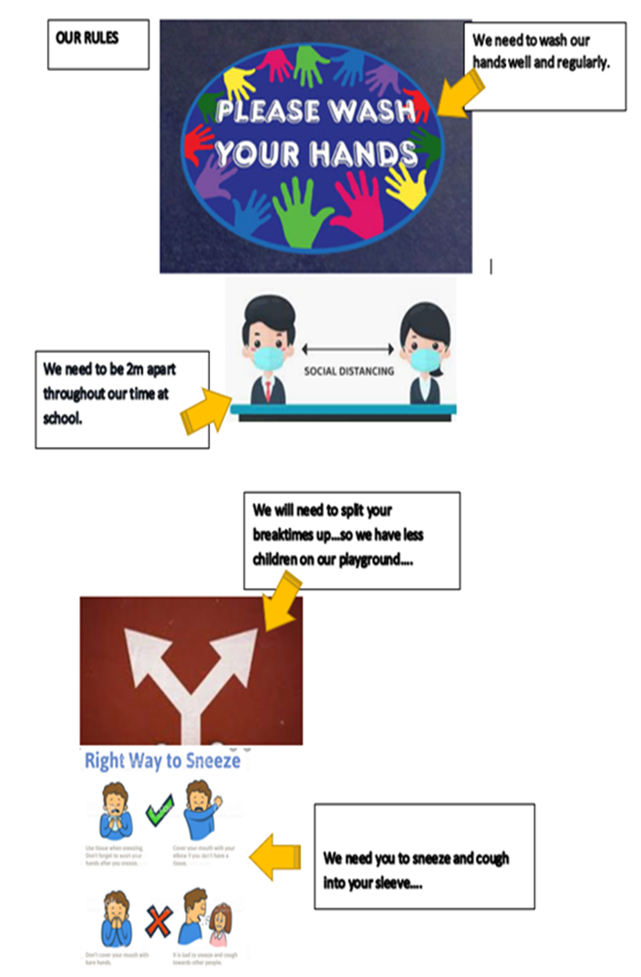

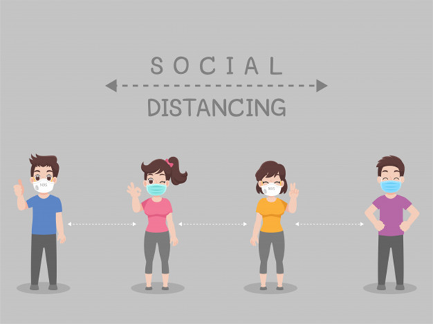

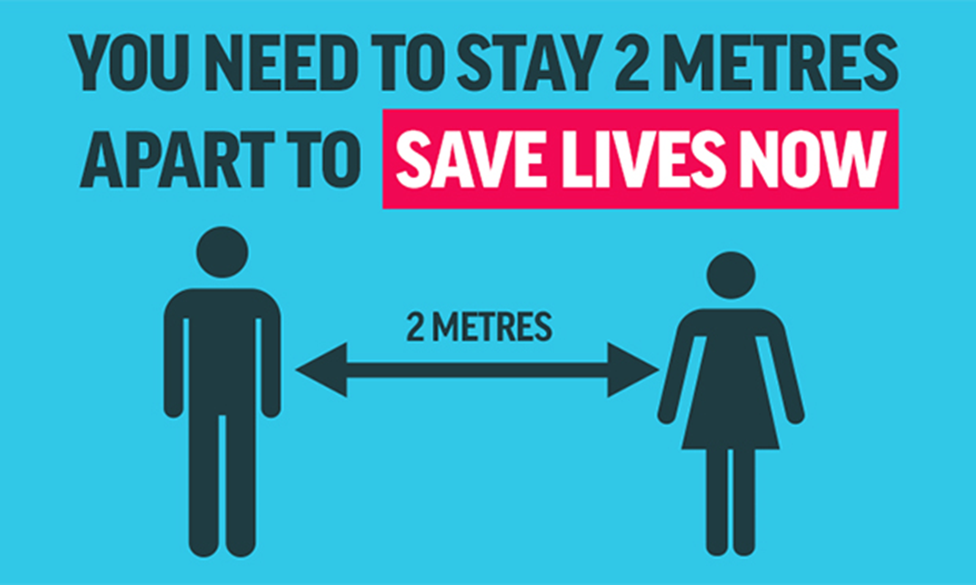
Tissue Disposal Signage for Designated Bins

Appendix 2 Signage outside of the academy to support social distancing and delivery expectations

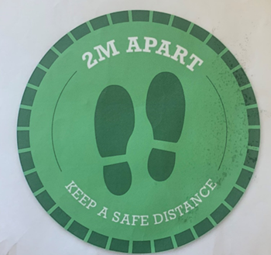

Signage on main entrance door
Appendix 3 Letter sent to parents to share academy expectations

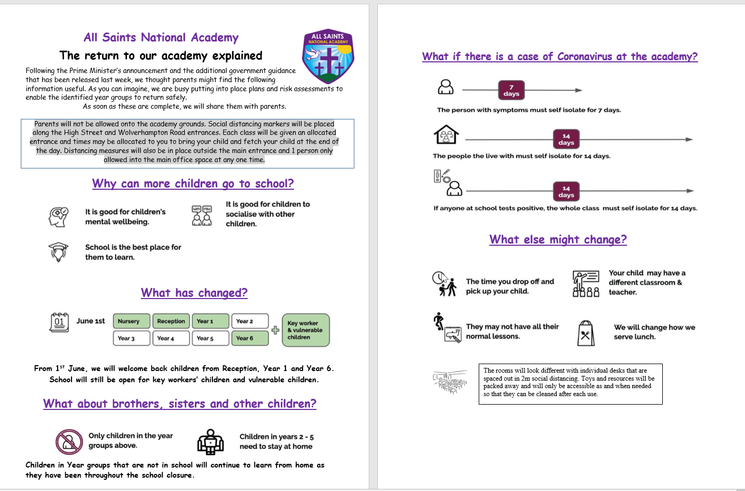
Appendix 4 – Local Management Plan

Appendix 5 External Map to show Designated Entrance and Exit Points
Reception entrance.
Queue to the right towards the park.
Year 1,2&5DB High Street Entrance
Queue to the left towards the academy main entrance

Year 3,4 & 5VL entrance. Wolverhampton Road Queue to the right towards the academy staff car park
Year 6 entrance. Staff Car Park Entrance
Barrier where staff will stand to welcome the children.
Barrier where staff will stand to welcome the children.
Any pupils who are late or have a designated plan for entry Main Entrance, using the designated one- way system.

